**B.TECH. (2020-24)**

**Artificial Intelligence**

Lab File

on

**Database Management Systems**

**[CSE201]**

Submitted To

**Dr Gaurav Dubey**

Submitted By

**Hitesh**

**A023119820027**

**4CSE11 (AI)**

DEPARTMENT OF COMPUTER SCIENCE AND ENGINEERING

AMITY SCHOOL OF ENGINEERING AND TECHNOLOGY

AMITY UNIVERSITY UTTAR PRADESH

NOIDA (U.P)

**DBMS LAB 3**

**SQL Queries**

**1. Write a query in SQL to display the last name and job title of all employees who do not have a manager**

**SQL Query**

**OUTPUT**

**2. Write a query in SQL to display the last name, salary, and commission of all employees who earn commissions. Sort data in descending order of salary and commissions.**

**SQL Query**

**OUTPUT**

**3. Write a query in SQL that prompts the user for a manager ID and generates the employee ID, last name, salary, and department for that manager's employees. The HR department wants the ability to sort the report on a selected column.**

**SQL Query**

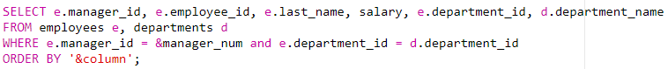

**INPUT**

$\boxed{manager_num = 100 and column = ‘last_name’}$

**OUTPUT**

**4. Write a query in SQL to Display all employee last names in which the third letter of the name is a.**

**SQL Query**

**OUTPUT**

